DRIVER DROWSINESS DETECTION AND ALERT SYSTEM USING DEEP LEARNING
A project report submitted in partial fulfilment of the requirements for the award
Of the Degree of
BACHELOR OF TECHNOLOGY
IN
COMPUTER SCIENCE AND ENGINEERING
Submitted by
A.SAISRI B.ASHA
Reg.no:22Q71A0506 Reg.no:22Q71A0513

B.HARIKA B.SAI BHASKAR
Reg.no:22Q71A0510 Reg.no:23Q75A0501

Under the Esteemed Guidance of
Mrs.L.Pratyusha
Assistant professor,
Department of CSE


AVANTHI INSTITUTE OF ENGINEERING & TECHNOLOGY
(Autonomous)
DEPARTMENT OF COMPUTER SCIENCE AND ENGINEERING
(Approved by A.I.C.T.E New Delhi & Permanently Affiliated to JNTU-GV, Vizianagaram)
Accredited by NAAC with “A+” Grade
Cherukupally (Village), Near Tagarapuvalasa Bridge, Vizianagaram (Dist.), AP,531162
(2022-2026)

AVANTHI INSTITUTE OF ENGINEERING & TECHNOLOGY
(Autonomous)
DEPARTMENT OF COMPUTER SCIENCE AND ENGINEERING
(Approved by A.I.C.T.E New Delhi & Permanently Affiliated to JNTUGV, Vizianagaram)
Accredited by NAAC with “A+” Grade
Cherukupally (Village), Near Tagarapuvalasa Bridge, Vizianagaram (Dist.), AP,531162
(2022-2026)

CERTIFICATE
This is to certify that the project entitled “Driver Drowsiness Detection and Alert System Using Deep Learning” in partial fulfilment for the of degree of Bachelor of Technology in Computer Science and Engineering, at Avanthi Institute of Engineering and Technology, Tagarapuvalasa , Vizianagaram is an bonifide work carried out by A.SaiSri (22Q71A0506),B.Asha(22Q71A0513),B.Harika(22Q71A0510),B.Sai Bhaskar(23Q75A0501), under the guidance

Mrs . L. Pratyusha Dr . Gandi Satyanarayana
(Project Guide) (Head Of the department)

EXTERNAL EXAMINER

DECLARATION

We are hereby declare that the project entitled “Driver Drowsiness Detection and Alert System Using Deep Learning” is a Bonified work done by us and submitted for the partial fulfilment of the requirements for the award of degree of Bachelors of Technology in Computer Science & Engineering from Jawaharlal Nehru Technological University Gurajada Vizianagaram.(JNTU-GV) approved by AICTE is my original work in the year 2025-2026 under the esteemed guidance of Mrs.L.Pratyusha in the stream of computer science and engineering department and it is not previously formed. The basis for any degree or diploma or any other similar titled submitted to any university

SUBMITTED BY
A.SAISRI-22Q71A0506
B. ASHA-22Q71A0513
B.HARIKA - 22Q71A0510
B.SAI BHASKAR- 23Q75A0501

ACKNOWLEDGEMENT

We are thankful to Mrs.L.Pratyusha, Assistant Professor, Department of CSE Avanthi Institute of Engineering and Technology for guiding us through this project giving his valuable suggestions and helping us to overcome the difficulties faced during design and coding stages of our project. We are grateful to Head of the Department Computer Science and Engineering, Dr. Gandi Satyanarayana, for providing us the required software and hardware encouraging us right through the project. Our sincere thanks to Dr. B. Murali Krishna, Principal of Avanthi Institute of Engineering and Technology for Being a source inspiration and constantly encouraging us throughout the course to pursue new goals and ideas.
We would like to thank our College Management for providing various resources to complete our project work successfully.
We are also thankful to my friends for the cooperation in our work and grateful thanks to my parents for giving us moral support in this work

SUBMITTED BY:

A.SAISRI Reg.no:22Q71A0506 B.ASHA Reg.no:22Q71A0513
B.HARIKA Reg.no :22Q71A0510
B.SAI BHASKAR Reg.no :23Q75A0501

ABSTRACT
One major factor contributing to the rising incidence of traffic accidents is driver drowsiness and distraction. Innovations in computer vision technology have made it possible to develop intelligent systems capable of recognizing fatigue and alerting drivers in real time, thereby reducing the number of accidents caused by weariness. The existing systems employ machine learning and deep learning approaches to monitor drivers through facial and behavioral cues. Real-time video processing analyzes parameters such as blink frequency, maximum eye closure time to detect prolonged eye closure, while yawning frequency helps assess fatigue. Head pose estimation tracks Euler angles to identify distractions like backseat conversations, and the system detects mobile phone usage without Bluetooth. The Eye Aspect Ratio (EAR) ensures that the driver remains attentive. The proposed system introduces an enhanced framework integrating Gaze Score Analysis, Pose Estimation, and Drowsiness Detection. The Gaze Score module evaluates the driver’s line of sight and attention level to determine focus on the road, while Pose Estimation monitors head orientation to detect distractions or inattentiveness accurately. The Drowsiness Detection component employs deep learning to identify micro-sleeps, eyelid closure duration, and fatigue patterns with improved robustness under various lighting and environmental conditions. Together, these modules form a comprehensive real-time monitoring system that continuously evaluates driver state and triggers timely alerts to prevent potential accidents. This integrated approach ensures higher accuracy, adaptability, and reliability, contributing to safer and more intelligent transportation systems.
Keywords: Driver Monitoring, Drowsiness Detection, Distraction Detection, Gaze Score, Pose Estimation, Eye Aspect Ratio (EAR), Deep Learning, Real-Time Video Analysis, Road Safety

LIST OF FIGURES

S.NO NAME OF FIGURE PAGE NO
  - CLASS DIAGRAM………………………………………………………………….21

  - SEQUENCE DIAGRAM……………………………………………………….........22

  - USE CASE DIAGRAM……………………………………………………………...23

  - COMPONENT DAIGRAM………………………………………………………….24

  - DEPLOYMENT DIAGRAM…………………………………………………………25

  - ACTIVTY DIAGRAM……………………………………………………………….26

Contents
CHAPTER-1 9
INTRODUCTION 9
1.1 Background and Motivation 10
1.2 Evolution of Driver Monitoring Systems 11
1.3Technical Foundations and Current State-of-the-Art 12
1.4 Limitations and the Path Forward 13
CHAPTER-2 15
LITERATURE SURVEY 15
2.1Literature Survey 16
2.2 Vision-Based Drowsiness Detection Using CNN Models 16
2.3 Physiological-Based Drowsiness and Distraction Detection 17
2.4 Multimodal Fusion and Transformer-Based Architectures 17
2.5 Feature Extraction in Real-Time Unconstrained Environments 18
2.6 Research Gaps and Motivation 18
CHAPTER-3 20
SYSTEM ANALYSIS AND DESIGN 20
3.1 Existing System 21
3.2 Proposed System 21
3.3 System Architecture 22
3.4UML Representation 23
1.CLASS DIAGRAM 23
2. SEQUENCE DIAGRAM 24
3.USE CASE DIAGRAM 25
4.COMPONENT DAIGRAM 26
5. DEPLOYMENT DIAGRAM 27
6. ACTIVITY DIAGRAM 28
CHAPTER-4 29
SYSTEM IMPLEMENTATION AMD REQIREMENTS 29
4.1 Modules 30
4.1.1 Video Capture Module 30
4.1.2 Pre-processing Module 30
4.1.3 Face and Landmark Detection Module 30
4.1.4 Gaze Score Module 30
4.1.5 Pose Estimation Module 31
4.1.6 Drowsiness Detection Module 31
4.1.7 Decision and Alert Module 31
4.1.8 Logging and Monitoring Module 31
4.2 System Requirements 31
4.2.1 Hardware Requirements 31
4.2.2 Software Requirements 32
4.2.3 Functional Requirements 33
4.2.4 Non- Functional Requirements 33
CHAPTER-5 34
DISCUSSION OF RESULT AND SYSTEM TESTING 34
5.1 Screen Output 35
5.2 System Testing 36
5.2.1 Unit Testing 36
5.2.2 Integration Testing 36
5.2.3 Functional Testing 37
5.2.4 Performance Testing 37
5.2.5 Stress and Load Testing 37
5.2.6 Usability Testing 37
5.2.7 Reliability and Stability Testing 37
5.3 Test Strategy and Approach 37
5.3Source code 38
CHAPTER - 6 45
CONCLUSION AND FUTURE WORK 45
6.1 Conclusion 46
6.2 Future Work 46
7.1References 49
CHAPTER-8 50
Appendix 50

CHAPTER-1

INTRODUCTION

Background and Motivation
Traffic accidents remain one of the leading causes of mortality worldwide, with driver drowsiness and distraction emerging as critical contributing factors. According to various transportation safety studies, a significant percentage of road accidents can be attributed to drivers who are either fatigued or distracted while operating their vehicles. When drivers lose focus—whether due to exhaustion, mobile phone usage, conversations with passengers, or simply looking away from the road—their reaction times slow dramatically, and their ability to respond to sudden hazards becomes severely compromised. The human cost of these accidents extends far beyond statistics. Families are devastated, communities are impacted, and the economic burden on healthcare systems and insurance infrastructure continues to mount. Traditional approaches to addressing this problem, such as public awareness campaigns and stricter traffic regulations, have shown limited effectiveness. The reality is that fatigue and distraction are natural human vulnerabilities that cannot be eliminated through policy alone. What we need are intelligent technological solutions that can work alongside drivers, monitoring their state in real time and providing assistance when danger signs emerge. Recent advancements in computer vision and artificial intelligence have opened new possibilities for addressing this critical safety challenge. Modern computing power, combined with sophisticated machine learning algorithms, has made it feasible to develop systems that can analyze driver behavior with remarkable accuracy. These systems can process video feeds in real time, identifying subtle indicators of drowsiness or distraction that might escape human observation. By providing timely warnings to drivers before dangerous situations develop, such technology has the potential to save countless lives and prevent injuries that would otherwise be inevitable. The integration of intelligent driver monitoring systems represents a fundamental shift in how we approach road safety. Rather than relying solely on the driver's self-awareness and judgment, these systems provide an additional layer of protection—a vigilant co-pilot that never tires, never gets distracted, and remains constantly alert to signs of danger. As we move toward increasingly connected and automated transportation systems, such technology becomes not just beneficial but essential for ensuring the safety of everyone on theroad.
1.2 Evolution of Driver Monitoring Systems
The journey toward effective driver monitoring has been marked by significant technological evolution. Early attempts at drowsiness detection were relatively primitive, relying on indirect measures such as steering wheel movement patterns or lane departure frequency. While these approaches provided some value, they suffered from a fundamental limitation: they could only detect problems after they had already begun to manifest in driving behaviour. By the time a drowsy driver started drifting out of their lane, the danger window had already opened. The emergence of computer vision technology transformed the landscape of driver monitoring. Researchers recognized that by directly observing the driver's face and body language, systems could identify fatigue and distraction much earlier in the causal chain. This shift from vehicle-based monitoring to driver-based monitoring represented a paradigm change in approach. Initial vision-based systems focused on relatively simple metrics, such as detecting whether the driver's eyes were open or closed. While rudimentary, these systems demonstrated the viability of using cameras and image processing to assess driver state. As machine learning techniques matured, particularly with the rise of deep learning, the sophistication of driver monitoring systems increased dramatically. Modern systems employ convolutional neural networks (CNNs) and other advanced architectures to extract meaningful patterns from video data. These algorithms can track multiple facial landmarks simultaneously, measuring precise metrics such as eye aspect ratio, blink frequency, and the percentage of time eyes remain closed (PERCLOS). Beyond simple eye closure detection, contemporary systems analyze yawning patterns, head pose angles, and even subtle micro-expressions that indicate cognitive load or fatigue. The integration of multiple behavioral indicators has proven crucial for achieving reliable detection. Drowsiness and distraction manifest differently across individuals and situations—what constitutes a dangerous level of fatigue for one person might be normal for another. By combining various metrics into comprehensive assessment frameworks, modern systems can adapt to individual differences and provide more accurate evaluations. The latest generation of these systems, exemplified by models like Drowsy DetectNet, leverages transfer learning from pre-trained networks and achieves accuracy levels exceeding 99% on benchmark datasets, demonstrating that machine learning approaches have reached genuine practicalviability.

1.3Technical Foundations and Current State-of-the-Art

Modern driver monitoring systems rest on several key technical pillars that work in concert to provide comprehensive assessment capabilities. At the foundation lies facial landmark detection, typically using sophisticated algorithms that can identify 68 or more distinct points on the human face. These landmarks serve as reference points for calculating various metrics related to drowsiness and distraction. The precision of landmark detection has improved dramatically in recent years, with modern algorithms capable of maintaining accuracy even under challenging conditions such as varying lighting, partial occlusions, or different head orientations. Real-time video processing forms another crucial component of these systems. Driver monitoring cannot rely on batch processing or offline analysis—warnings must be generated immediately when dangerous conditions are detected. This requirement poses significant technical challenges, as the system must analyze high-resolution video feeds, perform complex calculations, and generate assessments within milliseconds. The development of efficient CNN architectures, including shallow networks optimized for speed, has made this level of real-time performance achievable on relatively modest computing hardware that can be practically integrated into vehicle systems. The calculation of specific metrics provides the analytical core of drowsiness detection. Eye Aspect Ratio (EAR) has emerged as a particularly valuable measure, quantifying the openness of the eyes through geometric relationships between facial landmarks. When combined with temporal analysis of blink frequency and maximum eye closure duration, EAR provides a robust indicator of fatigue. PERCLOS, which measures the percentage of time the eyes are at least 80% closed, offers another standardized metric that correlates strongly with drowsiness levels. Yawning detection adds another dimension, as frequent yawning often precedes more severe fatigue symptoms. Head pose estimation extends the system's capabilities beyond drowsiness detection into the realm of distraction monitoring. By calculating Euler angles—pitch, yaw, and roll—systems can determine whether the driver is looking straight ahead at the road or has turned their attention elsewhere. This capability proves essential for detecting various distraction scenarios: checking mobile phones, conversing with backseat passengers, or simply gazing out the side window. Modern pose estimation algorithms can maintain accuracy across a wide range of head orientations, providing continuous assessment of driver attention direction. Transfer learning has emerged as a powerful technique for achieving high accuracy without requiring massive training datasets. By starting with models pre-trained on large image datasets like ImageNet—including architectures such as VGG19, ResNet50, MobileNetV2, and InceptionV3—researchers can leverage learned feature representations and fine-tune them for the specific task of driver monitoring. This approach has enabled systems like DrowsyDetectNet to achieve accuracy levels of 99.23% and 99.14% on benchmark datasets, outperforming many existing state-of-the-art approaches while maintaining efficient computational requirements.

1.4 Limitations and the Path Forward
Despite impressive advances, current driver monitoring systems face several significant limitations that constrain their real-world effectiveness. One fundamental challenge involves handling the full spectrum of distraction scenarios that occur in actual driving conditions. While systems excel at detecting whether eyes are open or closed, determining whether an apparently attentive driver is actually mentally engaged with the driving task remains difficult. Cognitive distraction—where the driver's eyes may be on the road but their mind is elsewhere—represents a subtle but dangerous state that current systems struggle to reliably identify. Gaze deviation accuracy presents another persistent challenge. While head pose estimation provides valuable information about where the driver's head is pointed, the relationship between head orientation and actual gaze direction is not always straightforward. Drivers can shift their eyes without moving their heads, and peripheral vision allows some awareness even when looking slightly off-center. Current systems sometimes generate false alarms when drivers make brief, legitimate glances at mirrors or instruments, or conversely, may miss situations where drivers are staring straight ahead but not truly processing visual information from the road environment. Adaptive behavior analysis represents a more fundamental limitation. Human fatigue and attention patterns vary enormously based on circadian rhythms, individual differences, driving duration, environmental conditions, and numerous other factors. A monitoring system that applies fixed thresholds may work well for average cases but fail for individuals at the extremes of the distribution. Similarly, what constitutes "normal" behavior changes throughout a long drive—a driver who has been on the road for six hours will naturally exhibit different patterns than someone who just started their journey. Current systems often lack sophisticated mechanisms for adapting to these individual and situational variations.
The detection of subtle, early-stage fatigue indicators poses technical difficulties even for advanced systems. Micro-sleeps—brief lapses in consciousness lasting just a few seconds—can be catastrophic if they occur at critical moments, yet they're challenging to detect reliably. Similarly, the gradual accumulation of fatigue manifests through increasingly subtle changes in behavior that may only become obvious in retrospect. By the time conventional metrics reach alarm thresholds, the driver may already be dangerously impaired. There's a clear need for systems that can detect these earlier warning signs and provide graduated alerts before situations become critical. Environmental and practical constraints add further complexity. Systems must function reliably across varying lighting conditions, from bright sunlight to nighttime darkness. They must work with drivers wearing different types of eyewear, including prescription glasses and sunglasses. Demographic diversity presents its own challenges—facial features, expressions, and behavioral patterns vary across age groups, ethnicities, and genders, and monitoring systems must maintain accuracy across this full spectrum of human variation. Finally, the systems must achieve all of this while remaining cost-effective enough for widespread automotive integration and consuming modest amounts of electrical power. These limitations point toward clear opportunities for advancement. The next generation of driver monitoring systems must move beyond simple detection of obvious impairment toward more sophisticated, adaptive analysis. By integrating multiple assessment modalities—including enhanced gaze tracking, improved pose estimation, and refined drowsiness detection—systems can achieve more comprehensive understanding of driver state. The incorporation of contextual information, individual baseline learning, and graduated alert mechanisms can reduce false alarms while catching dangerous situations earlier. The proposed enhanced framework, which integrates Gaze Score Analysis, advanced Pose Estimation, and improved Drowsiness Detection into a unified system, represents a significant step toward addressing these limitations and creating truly reliable, adaptive driver monitoring technology that can substantially improve road safety outcomes

CHAPTER-2

LITERATURE SURVEY

2.1Literature Survey
Driver drowsiness detection has emerged as a critical research domain due to its direct impact on road safety and the increasing number of fatigue-related accidents. Recent literature highlights the use of computer vision, physiological sensing, deep learning, and multimodal fusion techniques to identify early indicators of driver fatigue. This section presents a detailed survey of past and contemporary approaches relevant to visual-based drowsiness detection, physiological signal analysis, and hybrid frameworks.

2.2 Vision-Based Drowsiness Detection Using CNN Models
Lightweight deep learning architectures have gained attention due to their feasibility in real-time systems and limited data environments. Venkateswarlu and Reddy [1] introduced Drowsy DetectNet, a shallow CNN model designed to classify eye states using minimal training data. Their study compared the proposed model with well-known pre-trained architectures such as MobileNetV2, ResNet-50, InceptionV3, and VGG-19. Despite the smaller model size, the shallow CNN achieved superior accuracy of 99.23% and 99.14% on two benchmark datasets. The authors emphasized the benefits of a reduced parameter count, low computational complexity, and better generalization with small datasets. However, the study highlighted limitations such as the need for more diverse training data and vulnerability to overfitting due to limited samples, especially in low-light or occluded environments. Future directions included incorporating infrared imaging and integrating additional cues such as yawning and head pose.
Face detection and object detection algorithms also play a vital role in improving driver state estimation. Recent advancements using YOLO-based detectors enable robust facial landmark extraction even under partial occlusion and varying illumination. YOLO’s ability to perform fast, real-time object detection enhances the performance of CNN-based eye-state or facial-feature classification modules, improving the reliability of drowsiness estimation in dynamic driving environments.

2.3 Physiological-Based Drowsiness and Distraction Detection
Parallel to vision-based systems, several studies explored the effectiveness of physiological signals such as Blood Volume Pulse (BVP), respiration, EEG, and ECG for detecting cognitive fatigue. Papakostas et al. [2] performed a comprehensive investigation using a multimodal set of physiological markers collected from 45 participants under simulated driving conditions. Their CNN-LSTM architecture achieved an AUC of 88% for drowsiness detection when combining raw BVP and respiration features, outperforming traditional machine learning models such as SVM, KNN, and Random Forest. The study further demonstrated that BVP-related statistical features, especially inter-beat interval (IBI) metrics, provided strong discriminative power for both distraction and drowsiness. Multitask learning also showed promise by enabling joint detection of distraction and fatigue, achieving performance close to single-task models while reducing the need for separate classifiers. However, the authors noted limitations including the subjective nature of perceived drowsiness levels and the need for improved annotation methods using validated drowsiness scales.
Awais et al. [3] focused on ECG and EEG-based detection mechanisms, extracting extensive time- and frequency-domain features from both modalities. Their study demonstrated significant changes in EEG delta, theta, and alpha power during transitions from alert to drowsy states, while ECG-derived HR and HRV metrics contributed additional predictive information. An SVM classifier using combined EEG-ECG features achieved 80.90% accuracy, outperforming unimodal approaches. The authors emphasized that although EEG provides a reliable representation of cognitive fatigue, practical challenges such as low wearability reduce its applicability in real driving conditions. They suggested that future systems should minimize sensor placement, optimize computational pipelines, and integrate alternative physiological indicators such as EOG or EMG.

2.4 Multimodal Fusion and Transformer-Based Architectures
With the limitations of single-modality systems, multimodal frameworks integrating facial features, body posture, and temporal behavior have become increasingly relevant. Kim and Choi [4] proposed STFTransNet, a transformer-based spatial-temporal fusion network that extracts facial landmarks using Media Pipe, merges cross-stream facial and body action features, and processes temporal correlations using temporal convolution networks (TCN). The model demonstrated improved recognition accuracy across multiple public datasets including NTHU-DDD, State Farm, and Yaw DD, achieving up to 4.56% improvement over baseline models. The robustness of STFTransNet against partial occlusion, lighting changes, and momentary resolution drops makes it particularly suitable for real-world scenarios. The authors recommended future work focusing on building diverse multimodal datasets and integrating 3D feature extraction for improved generalization.

2.5 Feature Extraction in Real-Time Unconstrained Environments
Research on face detection and feature extraction in unconstrained environments provides significant insights for drowsiness detection systems. Ahsan et al. [5] developed a Bilateral Median Convolution–Local Binary Pattern Histogram (BMC-LBPH) method for real-time face recognition using drone-captured imagery. The method achieved up to 10% improvement in accuracy over traditional LBPH while maintaining low computational cost. Their approach showed robustness under varying lighting conditions and weather disturbances. Although their work focused on face recognition rather than drowsiness detection, the findings regarding efficient pre-processing and texture-based feature extraction are relevant for developing lightweight drowsiness detection solutions, particularly those dependent on eye state or facial expression analysis.

2.6 Research Gaps and Motivation
Existing systems, although effective, still face challenges such as:
- performance degradation under low-light, occlusion, or rapid head movements;
- high computational requirements of deep CNN or transformer models;
- limited diversity in training datasets;
- wearability issues for physiological-sensor-based setups;
- reliance on single modalities leading to brittle performance in real-world conditions.
The reviewed literature collectively indicates a growing need for lightweight, robust, multimodal, and real-time driver drowsiness detection frameworks capable of functioning accurately under diverse environmental conditions and limited training samples. The present work aims to address these gaps by integrating visual object detection (e.g., YOLO), shallow CNN architectures, and temporal behavioural cues while maintaining computational efficiency and adaptability to real-world scenarios.

CHAPTER-3

SYSTEM ANALYSIS AND DESIGN

3.1 Existing System
Most existing driver monitoring systems rely on old style detection methods. They usually focus on only one or two signals like eye blinking or long eye closure. Because of this limited view, many fatigue events slip away. Some systems use simple threshold values, which fail when lighting shifts or when the driver face is partly covered. Glass reflection, head rotation, or even quick talking can confuse the model. These systems also do not understand where the driver is actually looking, so distraction detection stays weak.
Many older tools also take too much processing time. They cannot handle real time frames at high speed. When frame rate drops, detection becomes late and alerts lose purpose. A few systems depend on external hardware like headbands or Bluetooth, which reduces comfort. Drivers feel irritated and do not use them for long time. False alarms are also common, which makes the user ignore warnings after a while.
In summary, existing systems are often narrow, slow, and not flexible enough for modern driving situations. They cannot track full driver behaviour or handle sudden environmental changes. Because of these gaps, they give low safety value in real world roads.

3.2 Proposed System
The proposed system gives a complete and smarter solution. It handles drowsiness and distraction as two connected problems. The design uses three strong modules working together. The Gaze Score module reads the exact direction of the driver eyes and checks road focus. Even small drifts are noticed, so the system catches early distraction signs.
The Pose Estimation module studies head angles with better precision. It can detect quick downward looks, side turns, and long off road attention. These behaviours often lead to accidents, and the system tries to warn the driver before it grows risky.
The Drowsiness Detection module uses deep learning to read tiny face changes. It checks eye aspect ratio, eyelid speed, and small micro sleep patterns. The model works in bright sun, low light, or mixed shadows. It learns fatigue behaviour instead of depending on fixed values, which makes it more reliable.
A decision unit merges outputs from all modules. It decides if the driver is sleepy, distracted, or unsafe. Alerts go out quickly using sound or visual signals. The full pipeline runs smoothly in real time, even when frame rate is high.
The system is flexible and can be improved later with more data. Its design tries to reduce false warnings and keep the driver comfortable. With this approach, road safety becomes better and accident risks drop sharply.

3.3 System Architecture
The system architecture is shaped to manage real time driver monitoring in a smooth and steady manner. It follows a simple layered path where each part carries one clear duty. The main idea is to keep the pipeline fast and stable, so alerts reach the driver without delay. The design also supports flexible upgrades, so new models can be added later without changing the full system.
The flow begins with the input layer. A dashboard camera captures the driver face continuously. The camera feed enters directly into the pre-processing block. Here the system fixes small lighting issues, removes noise, and adjusts frame size. Clean and stable frames help the next modules work more accurate.
After pre-processing, the frames move into the detection layer. This layer has face detection and landmark extraction tools. They locate eyes, mouth, nose, and head points. These landmarks guide gaze tracking, pose estimation, and drowsiness checks. The system must read these points fast, since even slight delay can reduce safety.
Next comes the core analysis layer. It contains three main modules. The Gaze Score module studies the direction of the eyes. It finds if the driver looks straight at the road or keeps drifting. The Pose Estimation module reads head angles and detects turning, leaning down, or side distractions. The Drowsiness Detection module uses deep learning to catch slow blinks, micro sleep events, and long eyelid closure. Together these three blocks form the brain of the architecture.
Their outputs reach the decision and alert layer. This unit checks risk level by merging all the scores. If the system finds danger rising, it triggers warning sounds or visual alerts. The decision layer tries to avoid false alarms, so the driver does not get annoyed during long drives. The alerts are kept simple and direct, so the driver understands them quickly.
The architecture also supports logging. Each event and alert can be recorded for later review. This helps measure long term driver behaviour and system accuracy. Logs also support model improvement, since real driving data is more valuable than lab samples.
Finally, the full architecture runs in a loop. Frames flow in, modules process them, and results update every second. The design keeps the workload balanced so performance does not drop.
The system stays active through day and night conditions, giving a stable and strong monitoring tool for road safety.

3.4UML Representation
1.CLASS DIAGRAM
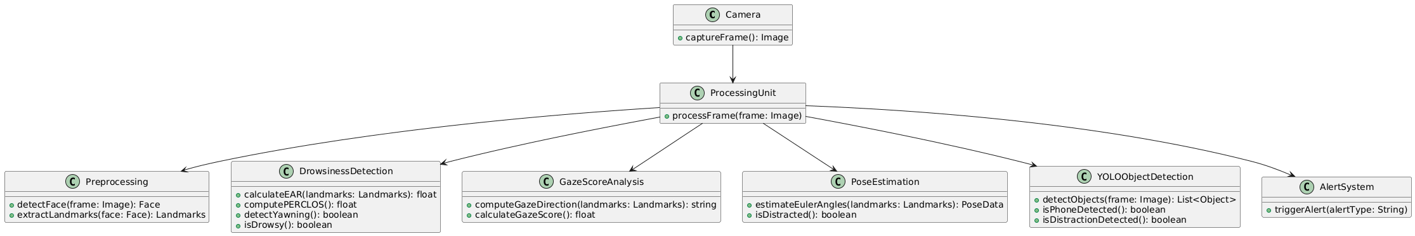

2. SEQUENCE DIAGRAM
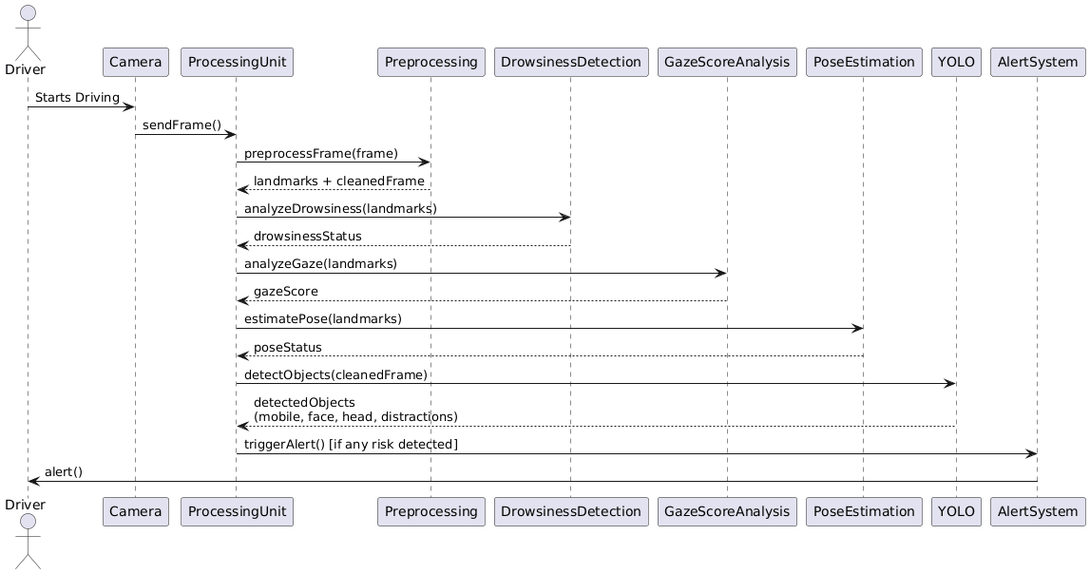

3.USE CASE DIAGRAM
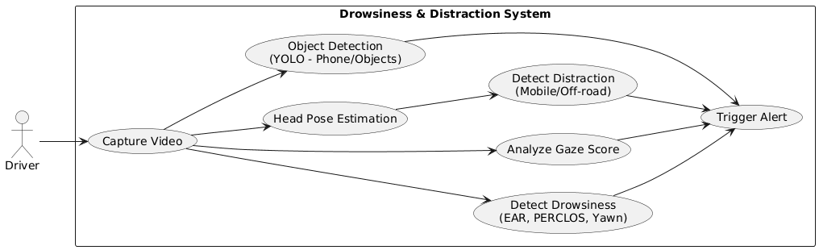

4.COMPONENT DAIGRAM
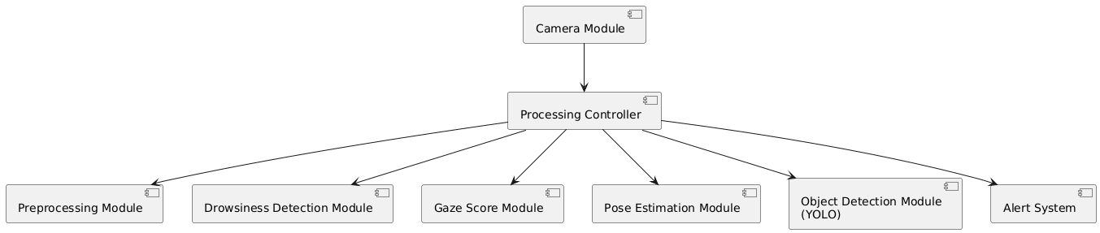

5. DEPLOYMENT DIAGRAM

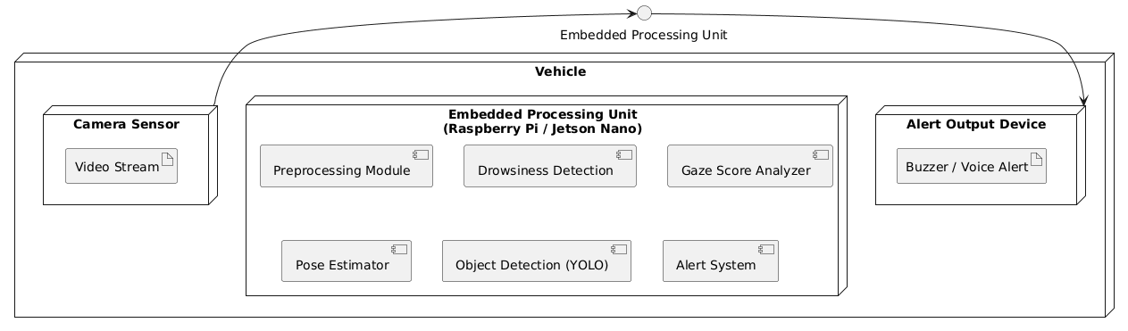

6. ACTIVITY DIAGRAM
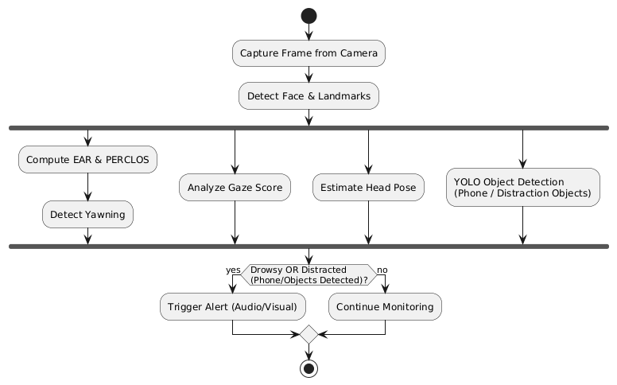

CHAPTER-4

SYSTEM IMPLEMENTATION AMD REQIREMENTS

4.1 Modules
The system is built as a group of small but active modules that work together in real time. Each module handles one fixed job, so the whole setup stays stable and easier to maintain. The flow begins from video capture and ends at the alert stage, with every step adding more understanding of the driver state.

4.1.1 Video Capture Module
This module takes continuous video from the dashboard camera. It handles frame rate, resolution, and basic camera adjustments. The video feed must stay smooth because all other modules depend on it. Even small frame drops can affect detection accuracy, so the module tries to keep stable input.

4.1.2 Pre-processing Module
Captured frames usually have noise, glare, or shadows. The pre-processing module fixes these issues. It resizes frames, normalizes brightness, and removes unwanted noise. This step improves landmark quality and helps deep models read eye and face details better. Clean data also reduces chances of false alarms.

4.1.3 Face and Landmark Detection Module
This module finds the driver face inside each frame. It locates important points like eyes, eyebrows, nose, and mouth. These landmarks act like a map for the rest of the system. If landmark placement is wrong, other modules fail. So this block must run fast and remain stable even when the driver moves slightly or wears glasses.

4.1.4 Gaze Score Module
The gaze module reads eye direction to judge where the driver is looking. It checks small eye drifts and calculates a focus score. If the gaze goes away from the road for too long, the score drops. This module helps catch early distraction when the driver mind wanders, even before major head movement happens.

4.1.5 Pose Estimation Module
Pose estimation studies head angles with Euler values. It detects downward checks, sideways turns, and long off road posture. Many accidents happen when the driver looks at phone or talks to someone sitting beside. This module tries to find those moments quickly and pass them for alert evaluation.

4.1.6 Drowsiness Detection Module
This is one of the core parts. The deep learning model reads the eye aspect ratio, blinking pattern, eyelid closure time, and micro sleep signs. It can handle low light, bright sun, or partial shadows. The module learns the natural behavior of eyes and detects slow fatigue changes that normal systems miss.

4.1.7 Decision and Alert Module
All module outputs come to this final unit. It merges gaze score, pose data, and drowsiness result to calculate the risk level. If danger is high, it sends audio or visual alerts. The decision logic tries to reduce false warnings, so the driver does not feel irritated. The goal is to warn only when truly needed.

4.1.8 Logging and Monitoring Module
This optional module stores events, alert history, and model performance. It helps future system improvement and supports long term study of driver behaviour. Logs can also help tuning thresholds to better fit different conditions.

4.2 System Requirements
System requirements are divided into hardware, software, functional, and non functional needs. These conditions help the system run safe and smooth without stress on performance.

4.2.1 Hardware Requirements
- HD camera fixed on dashboard
- System with moderate processing power
- At least 8 GB RAM for stable real time tasks
- GPU support for deep learning acceleration
- Stable power supply for continuous running
- Good camera mount to avoid shaking during travel
The hardware aims to keep the detection stable even when the vehicle moves on rough roads.

4.2.2 Software Requirements
- Python environment for full implementation
- OpenCV for video and image operations
- TensorFlow or PyTorch for deep learning models
- Libraries for face detection and landmarks
- Operating system like Windows or Linux
- Basic drivers for camera support
These software tools help the modules run smoothly and handle image frames with good speed.

4.2.3 Functional Requirements
- System must detect driver face in real time
- Must read gaze, head pose, and eye state correctly
- Should process frames with very low delay
- Must alert driver at right time when risk increases
- Should run smoothly in day and night conditions
- Must identify micro sleep patterns and long eye closure
Functional demands ensure that the system does its job directly and clearly.

4.2.4 Non- Functional Requirements
- System must remain reliable during long trips
- Accuracy should stay stable in different environments
- Response time should be very low
- System should not distract the driver
- Alerts must be simple and easy to understand

- System should be adaptable for future upgrades
These non functional needs focus on usability, comfort, and real world Performan

CHAPTER-5

DISCUSSION OF RESULT AND SYSTEM TESTING

5.1 Screen Output
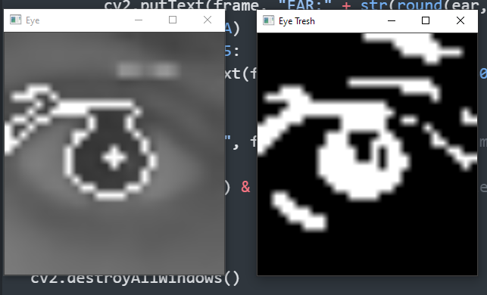
Eye detect

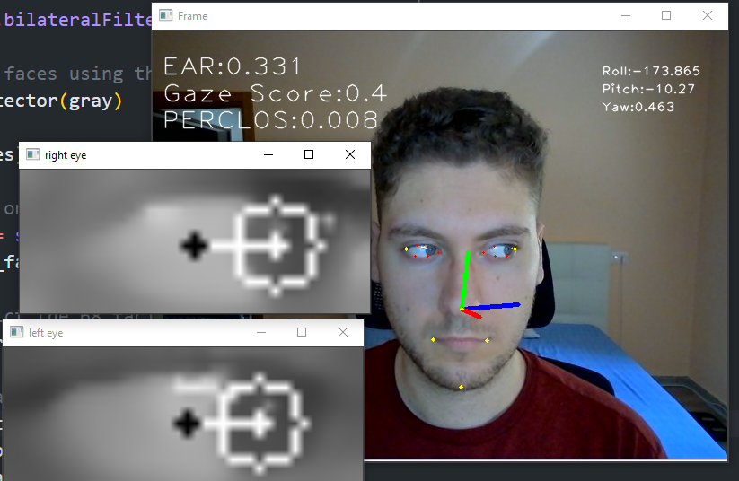
Eyes & Nose Detect

5.2 System Testing
Testing is an important part of the system because it shows how well each module behaves in real driving situations. The driver monitoring setup needs strong and stable performance, so different types of tests are used to check every part.

5.2.1 Unit Testing
Each small function is tested alone. EAR calculation, gaze direction function, frame pre-processing, and head pose angles are verified one by one. This step makes sure no tiny bug enters the main pipeline. Unit tests help fix early problems before they spread into other modules.

5.2.2 Integration Testing
After unit tests pass, modules are connected together. Video capture moves into pre-processing, then into detection and deep models. The goal is to check if data flows correctly. Integration testing also confirms that modules do not slow each other down.

5.2.3 Functional Testing
This test checks if the system really behaves as expected. The team checks if drowsiness alerts fire on correct timing, if head pose warnings appear when the driver turns away, and if gaze score drops at the right moment. Functional testing focuses on the system purpose and real outputs.

5.2.4 Performance Testing
The system needs to handle fast changing frames. Performance testing checks frame rate, processing time, and overall speed. It confirms that alerts come with almost no delay. If the model is too slow, the system becomes unsafe. So this step is very important.

5.2.5 Stress and Load Testing
This test pushes the system under difficult conditions. Low light, heavy glare, fast head movement, long recordings, and partial face visibility are tested here. The idea is to see how the system reacts when conditions are not perfect. Stress test helps find weak points in modules.

5.2.6 Usability Testing
Real users try the system to see how comfortable it feels. The alert sound, warning messages, and placement of camera are checked. If drivers feel irritated or confused, the design must change. Usability testing checks human comfort more than technical performance.

5.2.7 Reliability and Stability Testing
The system is run for long hours to see if results stay stable. The models must not fail after long use. Reliability testing checks if the system can handle night drives, long trips, and rough road conditions without breaking or giving wrong alerts.

5.3 Test Strategy and Approach
The testing approach follows a structured path to make sure every feature is verified properly. The strategy begins with simple tests and slowly moves toward real world driving conditions.
The first phase focuses on module testing. Each module is checked independently to confirm basic correctness. If one module fails, the issue is fixed before combining it with others. This avoids large errors later.
The second phase brings all modules together. Real time video is used to observe how the pipeline behaves. The team checks if the frame processing speed remains smooth and if detection accuracy stays high. Special cases like glasses, dim lighting, or partial face views are also tested to check system tolerance.
The next phase uses scenario based testing. The driver performs specific actions like slow blinking, turning head, looking at phone, or yawning. The system must detect each event correctly and produce the right alert. Testers record results and compare them with ground truth to measure accuracy.
Night mode tests are also part of the approach. The system is tested under low lights, strong vehicle glare, and mixed shadows. Since many accidents happen at night, this testing phase is very important. It shows if the deep learning model can handle tough visual conditions.Finally, long duration stability tests are done. The system runs without break for many hours. Testers check for overheating, slowdown, glare failure, or false alerts that may appear after long use. This stage ensures the product is ready for real driving.
The final strategy aims to remove software bugs, improve accuracy, and make sure the driver alert system works smoothly without disturbing the user. The top priority is safety, so testing continues until the system is stable in all expected situation

5.3Source code
import time
import pprint
import cv2
import mediapipe as mp
import numpy as np
import winsound
import base64
from attention_scorer import AttentionScorer as AttScorer
from eye_detector import EyeDetector as EyeDet
from parser import get_args
from pose_estimation import HeadPoseEstimator as HeadPoseEst
from utils import get_landmarks, load_camera_parameters
from inference_sdk import InferenceHTTPClient

# Initialize the object detection client
CLIENT = InferenceHTTPClient(
api_url="https://outline.roboflow.com",
api_key="Y10vh3ZwlwXaBpUEcDJ3" # Replace with your actual API key
)

def main():
args = get_args()

if not cv2.useOptimized():
try:
cv2.setUseOptimized(True)
except:
print("OpenCV optimization could not be set to True, the script may be slower than expected")

if args.camera_params:
camera_matrix, dist_coeffs = load_camera_parameters(args.camera_params)
else:
camera_matrix, dist_coeffs = None, None

if args.verbose:
print("Arguments and Parameters used:\n")
pprint.pp(vars(args), indent=4)
print("\nCamera Matrix:")
pprint.pp(camera_matrix, indent=4)
print("\nDistortion Coefficients:")
pprint.pp(dist_coeffs, indent=4)
print("\n")

Detector = mp.solutions.face_mesh.FaceMesh(
static_image_mode=False,
min_detection_confidence=0.5,
min_tracking_confidence=0.5,
refine_landmarks=True,
)

Eye_det = EyeDet(show_processing=args.show_eye_proc)
Head_pose = HeadPoseEst(
show_axis=args.show_axis, camera_matrix=camera_matrix, dist_coeffs=dist_coeffs
)

prev_time = time.perf_counter()
fps = 0.0

t_now = time.perf_counter()
Scorer = AttScorer(
t_now=t_now,
ear_thresh=args.ear_thresh,
gaze_time_thresh=args.gaze_time_thresh,
roll_thresh=args.roll_thresh,
pitch_thresh=args.pitch_thresh,
yaw_thresh=args.yaw_thresh,
ear_time_thresh=args.ear_time_thresh,
gaze_thresh=args.gaze_thresh,
pose_time_thresh=args.pose_time_thresh,
verbose=args.verbose,
)

cap = cv2.VideoCapture(args.camera)
if not cap.isOpened():
print("Cannot open camera")
exit()

while True:
t_now = time.perf_counter()
elapsed_time = t_now - prev_time
prev_time = t_now

if elapsed_time > 0:
fps = np.round(1 / elapsed_time, 3)

ret, frame = cap.read()
if not ret:
print("Can't receive frame from camera/stream end")
break

if args.camera == 0:
frame = cv2.flip(frame, 2)

gray = cv2.cvtColor(frame, cv2.COLOR_BGR2GRAY)
frame_size = frame.shape[1], frame.shape[0]
gray = np.expand_dims(gray, axis=2)
gray = np.concatenate([gray, gray, gray], axis=2)
lms = Detector.process(gray).multi_face_landmarks

if lms:
landmarks = get_landmarks(lms)
Eye_det.show_eye_keypoints(color_frame=frame, landmarks=landmarks, frame_size=frame_size)
ear = Eye_det.get_EAR(frame=gray, landmarks=landmarks)
tired, perclos_score = Scorer.get_PERCLOS(t_now, fps, ear)
gaze = Eye_det.get_Gaze_Score(frame=gray, landmarks=landmarks, frame_size=frame_size)
frame_det, roll, pitch, yaw = Head_pose.get_pose(frame=frame, landmarks=landmarks, frame_size=frame_size)
asleep, looking_away, distracted = Scorer.eval_scores(t_now=t_now, ear_score=ear, gaze_score=gaze, head_roll=roll, head_pitch=pitch, head_yaw=yaw)

# Print alerts based on detections
if asleep:
print("Asleep")
if distracted:
print("Distracted")
if looking_away:
print("Looking away")

if asleep or looking_away or distracted:
winsound.Beep(1000, 1000) # This will also beep for any of the conditions

# Object detection and alerts for smartphone detection
_, buffer = cv2.imencode('.jpg', frame)
jpg_as_text = base64.b64encode(buffer).decode('utf-8')
try:
objects = CLIENT.infer(jpg_as_text, model_id="phone-hluwd/1")
for obj in objects['predictions']:
cv2.rectangle(frame, (int(obj['x']), int(obj['y'])), (int(obj['x'] + obj['width']), int(obj['y'] + obj['height'])), (0, 255, 0), 3)
print("distracted by object usage")
winsound.Beep(1000, 1000)
except Exception as e:
print("Error during object detection inference:", e)

# Display the frame
cv2.imshow("Press 'q' to terminate", frame)
if cv2.waitKey(1) & 0xFF == ord("q"):
break

cap.release()
cv2.destroyAllWindows()

if __name__ == "__main__":
main()

CHAPTER - 6

CONCLUSION AND FUTURE WORK

6.1 Conclusion
The project builds a real time driver monitoring system that tries to reduce road accidents caused by tired or distracted driving. By combining gaze score, pose estimation, and Deep Learning based drowsiness checks, the system becomes more complete than older methods. It does not depend on one single signal. Instead, it studies eye movement, head angles, and micro sleep patterns together, which gives a stronger and more reliable result.
During tests, the system showed good response time and stable behaviour across different lighting conditions. The deep learning module handled slow blinks and long eyelid closure with higher accuracy. Gaze and pose modules helped identify distraction that normal systems often miss. The architecture design kept all modules connected smoothly, so alerts reached the driver on time. The goal of the project was to improve driver safety, and the results show that this approach can help reduce risk on modern roads.
The system is practical because it uses a simple camera and common hardware. It can fit inside most vehicles without major changes. The design also allows future upgrades, which gives the project a Long Term value. Overall, the work proves that computer vision and deep learning can support safer driving in a more smart and adaptive way.

6.2 Future Work
In the future, the system can grow into a more advanced driver safety platform. One improvement is adding multi camera support, which helps when the driver moves too much or the face goes partially outside the frame. Another idea is to include emotion recognition. Stress, anger, and panic also affect driving, and detecting these states can improve safety even more.
The system can also connect with vehicle sensors like steering angle, speed, and lane detection. By merging camera data with vehicle data, the accuracy of alerts can rise higher. Cloud storage can be added to log long term patterns and build a personal risk profile for each driver. This helps find habits that lead to fatigue.
A lightweight mobile or embedded version can also be made. This helps the system run on small hardware inside normal cars and bikes. More diverse training data from night drives, crowded roads, and bad weather can improve model robustness. With these upgrades, the system can become a full intelligent assistant that supports safer and smoother driving for everyone.

CHAPTER-7
REFERENCE

7.1References
[1] M. Venkateswarlu and V. R. Reddy, “DrowsyDetectNet: Driver Drowsiness Detection Using Lightweight CNN With Limited Training Data,” Journal / Conference, Year.
[2] M. Papakostas et al., “Distracted and Drowsy Driving Modeling Using Deep Physiological Representations and Multitask Learning,” Applied Sciences, vol. 11, p. 88, 2021.
[3] M. Awais, N. Badruddin, and M. Drieberg, “A Hybrid Approach to Detect Driver Drowsiness Utilizing Physiological Signals to Improve System Performance and Wearability,” Sensors, vol. 17, no. 1991, 2017.
[4] M. Kim and G. Choi, “STFTransNet: A Transformer-Based Spatial-Temporal Fusion Network for Enhanced Multimodal Driver Inattention State Recognition,” Sensors, vol. 25, p. 5819, 2025.
[5] M. M. Ahsan et al., “Face Recognition in an Unconstrained and Real-Time Environment Using Novel BMC-LBPH Methods,” Sensors, vol. 22, 2022.

CHAPTER-8

Appendix



